|  |
| --- |
| Worldwide Object Oriented Federation (WOOF) |
| MJ Logistics Gaming Company |
| Project Bark |

|  |
| --- |
| Joshua Gibson  7-18-2023  Version 1.0 |
|  |

Contents

A. Introduction 3

A1. Introduction and Purpose Statement 3

A2. Overview of the Problems 3

A3. Goals and Objectives 3

A4. Prerequisites 3

A5. Scope 3

A6. Environment 3

B. Requirements 4

Business Requirements 4

User Requirements 4

Functional Requirements 4

Non-Functional Requirements 4

C. Software Development Methodology 4

C1. Advantages and Disadvantages 4

Advantages of the Agile Method 4

Disadvantages of the Agile Method 4

Advantages of {A Different Method} 4

Disadvantages of {A Different Method} 4

C2. Best suited 5

D. Create Two Representations of the Software Solution 5

Representation 1 5

Representation 2 5

E. Testing 6

Test Name 1 6

Test Name 2 7

Test Name 3 8

F. Sources 8

# Introduction

# A1. Introduction and Purpose Statement

WOOF, Inc. Is proposing a solution to address MJ logistics Gaming Company’s query to find an answer to some growing concerns with the feasibility of their current system and future market demands. WOOF proposes a new CRM management system, Zoho CRM, to address MJ Logistics Gaming Company’s concerns and business objectives. The details of the proposal are found in the following sections of A. Introduction. The purpose of implementing the new Zoho CRM is to consolidate business data and to streamline business functions in order to create improved customer interactions.

# A2. Overview of the Problems

MJ Logistics Gaming Company has experienced an increase in sales over the past two years and the existing system is incapable of meeting current demands. Furthermore, there is potential to diversify into further markets, like producing movies, and would like a system that is flexible and easily adaptable to new markets.

The current system does not meet current demands of the business. Furthermore, it includes a myriad of tools and management systems spread across multiple offices, many of which also have employees that work remotely. The proposed Zoho CRM system will consolidate all the company data found in the various systems into one location. The system will also provide a set of new processes for the business to utilize in order to streamline customer interactions by providing accurate data quickly and efficiently to employees of MJ Logistics Gaming Company when interacting with customers. The new system will also provide the ability to scale according to the companies demand levels.

# A3. Goals and Objectives

Project Bark has the following objectives with its proposed solution:

Consolidate information into a central database

Control user access based on role within the company

Manage and provides reports of business activities and sales

Scale to future needs of the companies ventures

# A4. Prerequisites

|  |  |  |  |
| --- | --- | --- | --- |
| Number | Prerequisite | Description | Completion Date |
| 1 | Data Aquisition | Coallesce data from the current separate systems to be implemented in the new cloud software. | 7/30/2023 |
| 2 | Cloud Database Creation | Create the database to be used along with the Zoho CRM. | 8/6/2023 |
| 3 | Backup Creation | Update hardware at the selected sites to serve as backups of the data contained in the cloud database. | 8/13/2023 |
| 4 | Training Research | Assess user current experience with CRM software to determine depth of training required once system is implemented. | 8/20/2023 |

# A5. Scope

Provide a brief overview of what the proposed solution will cover and what the proposed solution will not cover. It is important to set clear boundaries for the project.

In Scope:

* Reports for various business activities
* Tracking sales data
* Tracking system for communications with contacts
* Managing orders from quote to completed sale
* Generating Quotes
* Predicting future sales and revenue

Out of scope:

* Changes in requirements
* Deadline changes
* Additional product features

# A6. Environment

Front-end will involve browser (all substantial browsers IE Chrome, Firefox, Microsoft Edge, etc) development allowing unfettered access to the employees of MJ Logistics Gaming Company.

Back-end of the project will entail a cloud-based service to maintain company records. AWS was chose due to its reliability and scalability. AWS has a very detailed service agreement for its customers. Under the service agreement, AWS makes a commitment to maintaining security and privacy of the customers data. Furthermore security and back up is clearly outlined as a customer responsibility, making decisions about upgrading company hardware and maintenance under the companies discretion. AWS provides four different support plans to customers, allowing the business to choose the one that best fits the businesses goals. If the company ultimately is unsatisfied with AWS at any point it can terminate the agreement by providing notice and closing the account with AWS.

In the event of an outage occurring with AWS the Zoho CRM will be configured to utilize one of the company sites that has been upgraded as a database backup. Development of the companies interactions will occur in the IDE AWS Cloud 9, which will allow development and testing of the code as to how it will interract with the AWS system.

MySQL will be used for the framework of the database. However, the company currently retains numerous locations with hardware currently available. Each location shall be updated and expanded to then become data backups for the cloud based service. Backup schedule to be determined at the request of MJ Logistics Gaming Company.

# Requirements

The following section addresses requirements of:

* Reporting
* Scalability
* Ticketing
* Rollback

Zoho CRM provides a very friendly GUI to track business data on sales versus business goals, reporting the current state of the business. Zoho CRM also allows the ability to scale based on the needs of the business as well as ticketing options. The data backups proposed in this plan will allow the company to maintain multiple records of the data in various locations and the ability to rollback the database records to an earlier time if an issue occurs with the main data storage in the cloud.

## Business Requirements

Figuring out the current state of your business to figure out where you stand and what you need to do to move to a desired outcome is a primary concern of every business. A lot of these decisions are made through reports generated based on data currently retained by the company. Zoho CRM provides a robust level of reporting options that can be customized to our clients needs.

## User Requirements

A base of 500 users concurrently using the system during peak times with the ability to scale to meet a growing number of users while maintaining performance standards. Zoho CRM prides itself on the ability to prove economical solutions to growing businesses to meet their demands.

## Functional Requirements

Zoho CRM provides a framework for a very robust system of monitoring tickets. Every communication is tracked and a plethora of information about each interaction is maintained in records. From who called, to why, when, etc. It also allows for notifications for followups.

## Non-Functional Requirements

WOOF’s proposed solution will allow the the company to maintain auditing and more importantly roll back requirements designated by the company. The proposed design plan is to utilize already available company assets and expand them to become backup data storage for the online cloud database that is utilized to allow increased user access. Auditing logs and critical data will be backed up at theses locations in case of a critical system failure that requires a reboot.

# Software Development Methodology

# C1. Advantages and Disadvantages

## Advantages of the Agile Method

A main advantage of the agile method is that it employs incremental changes at set intervals until completion of the project. This allows each change to be thoroughly tested, allowing bugs that may cause larger problems later if gone unnoticed to be identified.

A second advantage of the agile method is that as different iterations are released of the program to the customer it allows the customer to provide feedback on how the project is progressing. This process gives insight into what the customer currently likes about the project of suggestions of what direction they would like certain aspects to move towards before more work is completed.

A third advantage of the agile method is that the number one priority is customer satisfaction. Therefore a high level of communication is involved during all stages of development allowing for the greatest chance of delivering a product that satisfies the customers needs and expectations.

## Disadvantages of the Agile Method

An essential component of the agile method is communication between the development team and the customer. This can sometime create a disadvantage by creating greater demands on the participants. Furthermore, lack of participation on either end can hinder the project as well.

Projects devloped with the agile method are generally not as structured as other methodologies. This can sometime affect the anticipated time to complete the project in the desired time frame due to some aspects of development potentially falling of track from what was initially envisioned.

The agile method is not as rigid as other methodologies and is in fact quite flexible by nature. However great flexibility is, results are less predictable then more structured methodologies.

## Advantages of Waterfall Method

The waterfall method does is a rigid methodology that doesn’t allow the next phase of the project to begin without the previous stage being completed. Due to this, changes to what is to be done is virtually non existent.

The waterfall method comprises a clearly defined set of steps throughout the completion of the project. Each step of the project must be completed before the next step begins. Therefore, if complications arise and delays occur an accurate timeline to completion of the project can be achieved.

Each stage of the development a project that utilizes the waterfall methodology is designed to create a specific outcome. Therfore, a realized solution to the current step of the process leads to a more efficient transfer of information from the previous phase into the next.

## Disadvantages of {A Different Method}

One primary disadvantage of the waterfall method is that it is very inflexible. One step must finish before another begins. This can translate into greater costs for the project before final completion.

The waterfall method has predetermined requirements and the only focus during a project that utilizes this method is to reach those requirements. This particular approach often eliminates potential valuable feed back from the customer and potential users of the product.

Due to its rigid nature, testing does not occur until its designated phase of the project. This allows a greater opportunity for bugs to occur. Furthermore, bugs that were created early in the development process that were undetected can cause a multitude of headaches because the have now permeated to further development stages. This makes debugging significantly more difficult.

# C2. Best suited

The Agile methodology is vastly superior to other methodologies for this project for a number of reasons. MJ Logistics Gaming Company has a very detailed vision for the direction they would like this project to take with a long list of specific objectives. Due to this, regular communication between the development team and the customer will be required to determine if objectives are being met to satisfactory levels for the customer. Agile method, being customer satisfaction centric, provides the best framework for this to be accomplished.

Agile method uses an incremental agenda throughout a project’s development. This allows continuous testing throughout the development cycle; particularly increases the odds of bugs being detected early in development. This allows the project to run smother and for problem areas being identified and addressed early on, possibly allowing final completion to occur successfully apposed to other methodologies like waterfall. Furthermore, if a particular feature in the newest increment is unlike, not useful, or a list of other possible reasons the project can be quickly rolled back to the previous stage with little to no effort allowing further development without having to redo previous work.

# Create Two Representations of the Software Solution

A key concern being addressed is with the new system is determining where the company currently stands so that decisions can be made to meet the companies projections. Zoho CRM provides a very robust GUI to address this. Furthermore, with utilizing Zoho CRM, the workflow for sales people is significantly reduced. In the previous sytem, employees had to search through a variety of disparate systems to find all the information for as a sale. As we will see shortly, Zoho CRM drastically simplifies a sale.

## Representation 1

In MJ Logistics current system, company data is maintained over a variety of many disconnected manual and automated processes, causing various issues for salespeople to gather pertinent data when making sales. With Zoho CRM, everything is coalesced into one area and significantly simplified. The following shows the workflow the new system will bring.

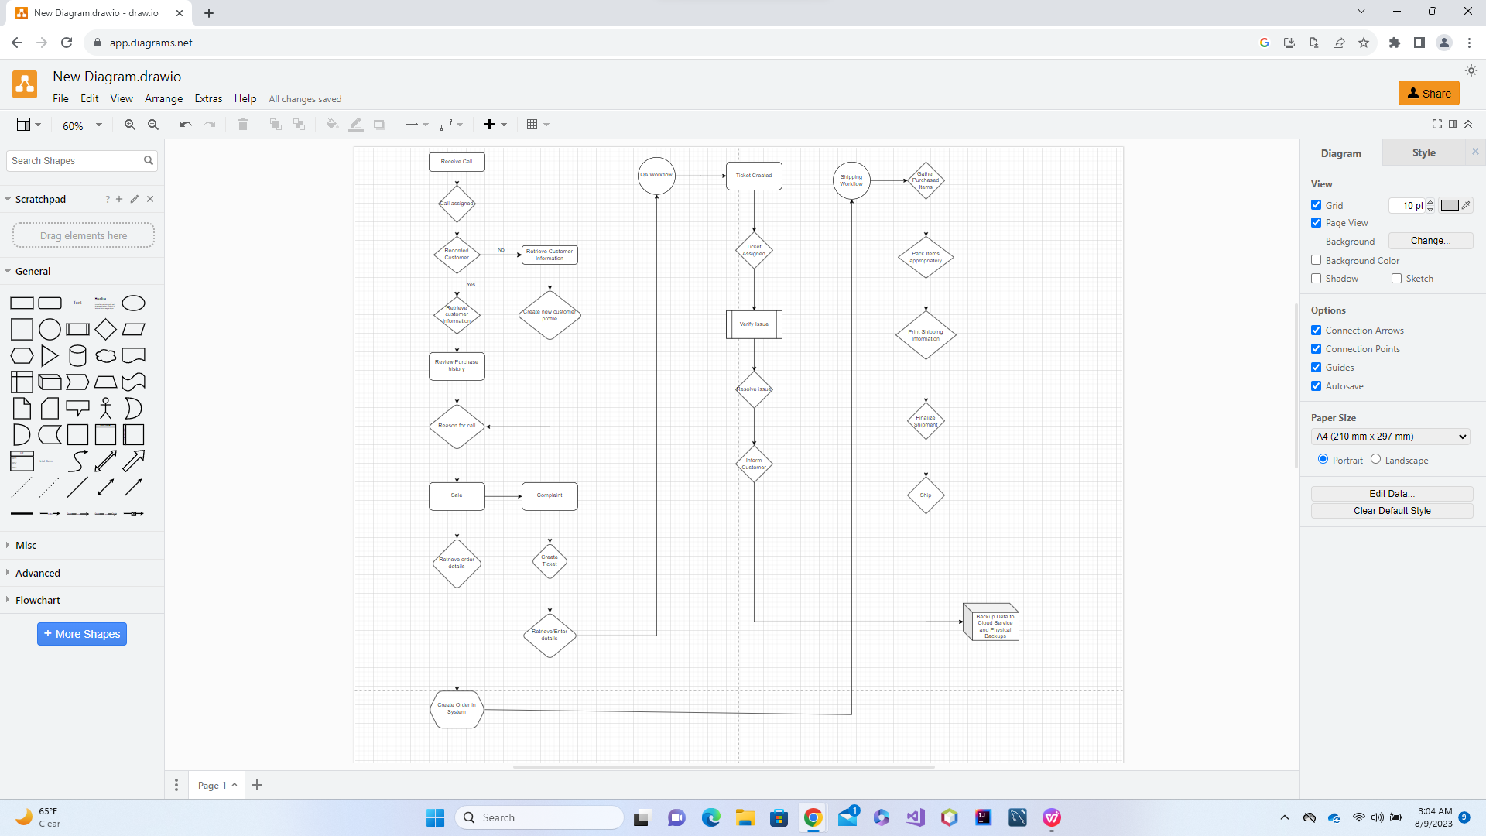

## Representation 2

Zoho CRM provides a very intuitive and robust user interface for users to quickly identify information pertinent to the days activities in order to effectually plan their work schedule. It also allow for the quick acquisition of customer information.

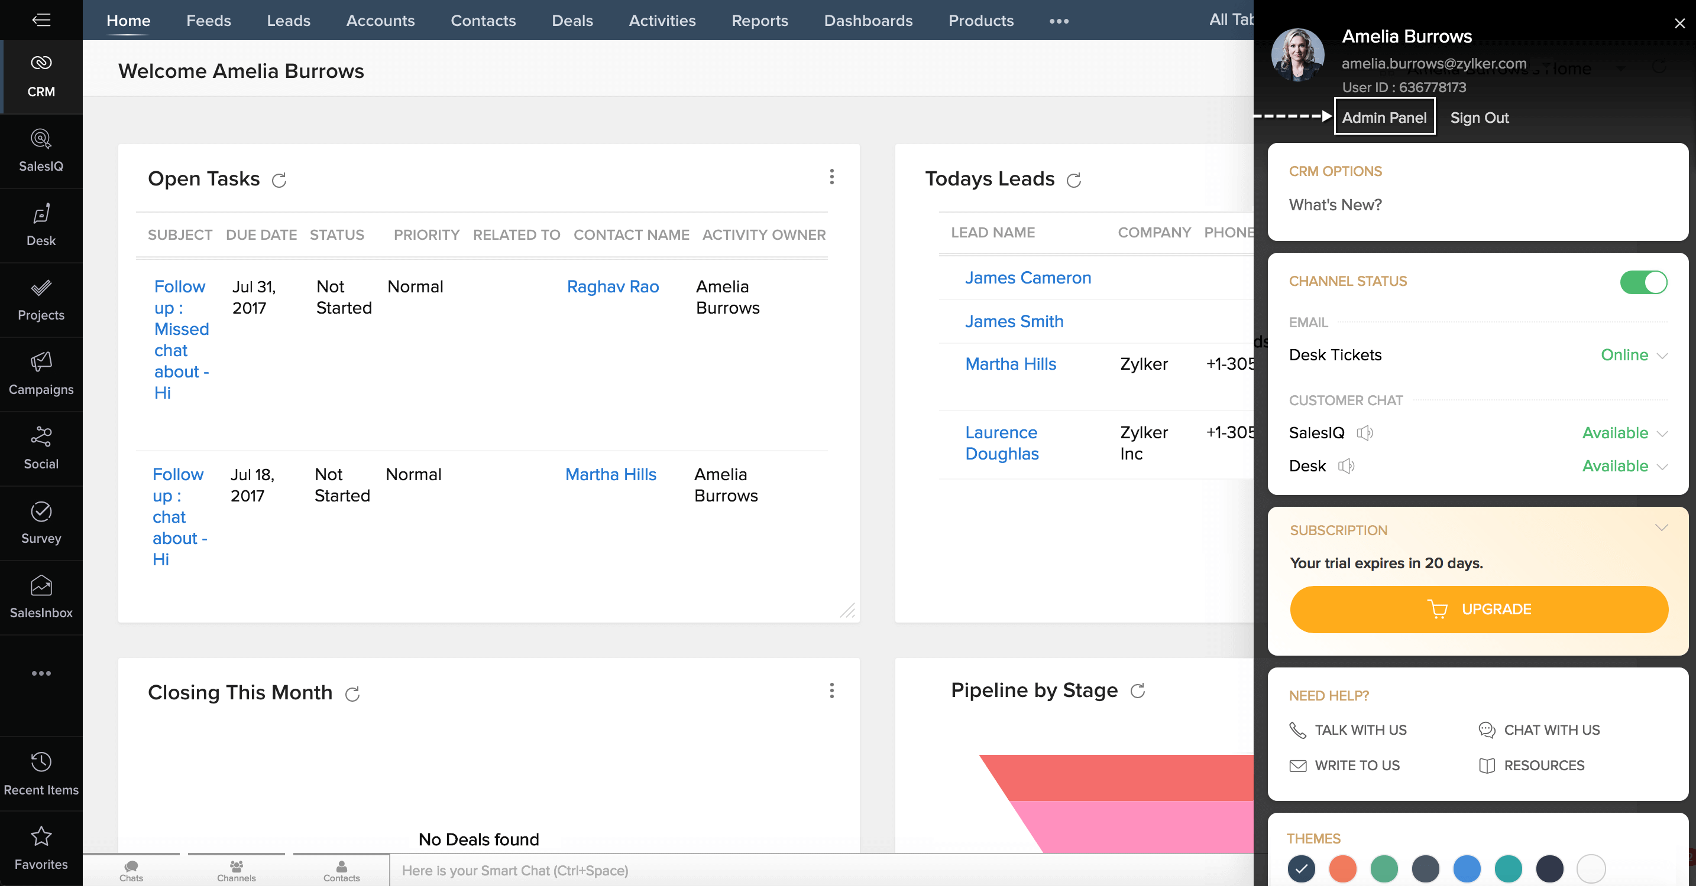

# Testing

# Rollback

|  |
| --- |
| Requirement to be tested:  Saving and restoring database data. |
| Preconditions:  Central cloud database created and all information stored within. Selected sites hardware and software upgraded to be used as data backups. Routines for backup and restore established. |
| Steps: The steps the tester must execute to test the feature.   1. Backup cloud data to each designated backup site. 2. Verify all data was correctly backed up. 3. Delete data from cloud database. 4. Initiate rollback procedure to restore lost data. 5. Verify all data was restored correctly. |
| Expected results:  Data from cloud based database is correctly backed up in designated sites and in the event of data loss backups properly restore lost data. |
| Pass/Fail:  Failure would occur if data is not correctly backup at designated sites or the cloud database could not retrieve backups from designated sites and retrieve crucial information if data was lost.  Pass would occur if data is correctly backed up and restored. |

# User Access

|  |
| --- |
| Requirement to be tested:  Managers, supervisors, salespeople, and HR are only allowed access to the features designated for their roles. |
| Preconditions:  Succinct parameters for what company information is available to managers, supervisors, salespeople, and HR representative when fulfilling their role. |
| Steps: The steps the tester must execute to test the feature.   1. Create test profiles for a manger, supervisor, salesperson, and HR representative. 2. Access each test profile. 3. View available information for each test profiles. 4. Confirm for each test profile that only the features designated for that role are available to the test   profile. |
| Expected results:  Managers, supervisors, salespeople, and HR only have access to company information and data that is necessary for them to fulfill their role within the company. |
| Pass/Fail:  Failure would occur if a role had access to features not designated for that role.  Success would occur if each role was only allowed access to company data and information that is required for them to perform their duties within the company. |

# Report generation and saving

|  |
| --- |
| Requirement to be tested:  Reports are properly generated and saved to the company database. |
| Preconditions:  List of reports desired by the company. The ability to generate each type of report and the ability to save reports. |
| Steps: The steps the tester must execute to test the feature.  (For each report in the list of desired reports)   1. Generate report. 2. Verify information in report is accurate based on company data that is on file. 3. Save the report. 4. Open the saved report. 5. Verify report is read-only. 6. Verify that the information in the saved report matches the information in the originally generated   report. |
| Expected results:  Each desired report can be generated and saved. Each saved report contains an exact copy of the original report. |
| Pass/Fail:  Failure if each type of desired report cannot be generated or saved; or the saved reports have altered data from what was originally in the report.  Success if each type of desired report can be generated and saved as well as contain an exact copy of the originally generated report when opened on a future date. |